Lesson 3 Demo 3: Viewing Logs in Multi-Container Pod

This section will guide you to:

* View logs in multi-container pod

This lab has one sub-section, namely:

1. Viewing logs in multi-container pod

**Note:** If you don’t have an existing Kubernetes cluster, refer to the Demo 1.1 of Lesson 1.

**Step 1:** Viewing logs in multi-container pod

* Check all the running pods

*kubectl get pods*

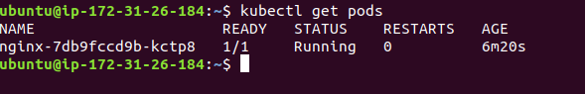

* To view logs of a pod running a single container, use the following command:

*kubectl logs <podname>*

***Note:*** *Replace podname with the name of the pod*

* View all the logs of a pod running a single container inside it. This will also show the appending logs at run time. This can be achieved via running command:

*kubectl logs -f <podname>*

***Note:*** *Replace podname with the name of the pod*

